Propaganda for patriotism and nationalism
- Article by:David Welch
- Theme:Propaganda
- Published:29 Jan 2014
Professor David Welch explores nations’ reliance on propaganda in World War One, with a focus on symbols and slogans of nationhood and patriotism.

The First World War was the first war in which the mass media played a significant part in disseminating news from the Fighting Front to the Home Front. It was also the first war to target systematically produced government propaganda at the general public. All the belligerents were therefore compelled to recognise that they had to justify the righteousness of the war and, to this end, themes such as patriotism and nationalism played an important role.

‘Your Country Needs YOU’
The armies of continental Europe were made up of conscripts, who really had little choice about going to war. In 1914 the British Army, by contrast, was made up of professionals and then volunteers. The British placed immense reliance, therefore, on propaganda to justify the war to the people, to help promote recruitment into the armed forces and to convince the population that their sacrifices would be rewarded. One of the most enduring images of the war - much copied and parodied since - remains the distinctive recruitment poster of Lord Kitchener’s heavily mustachioed face and intimidating finger imploring the British population that ‘Your Country Needs YOU’. Stereotypes deeply embedded in national sentiment were invoked to justify Britain’s entry into the war, and British propaganda posters often employed the religious symbolism of St George slaying the (German) dragon.British recruitment posters changed in tone, from appealing to an individual’s honour to ‘mobilisation by shame’. Savile Lumley’s famous poster of 1915 depicted two young children asking their father about his military prowess after the war: ‘Daddy, what did YOU do in the Great War?’ The emotional blackmail of using children to shame their elders into fighting was, in fact, employed by most of the belligerents. Women were also assigned the responsibility for ordering men into war. Perhaps the most well known in this genre is ‘Women of Britain Say—“GO!”’

- 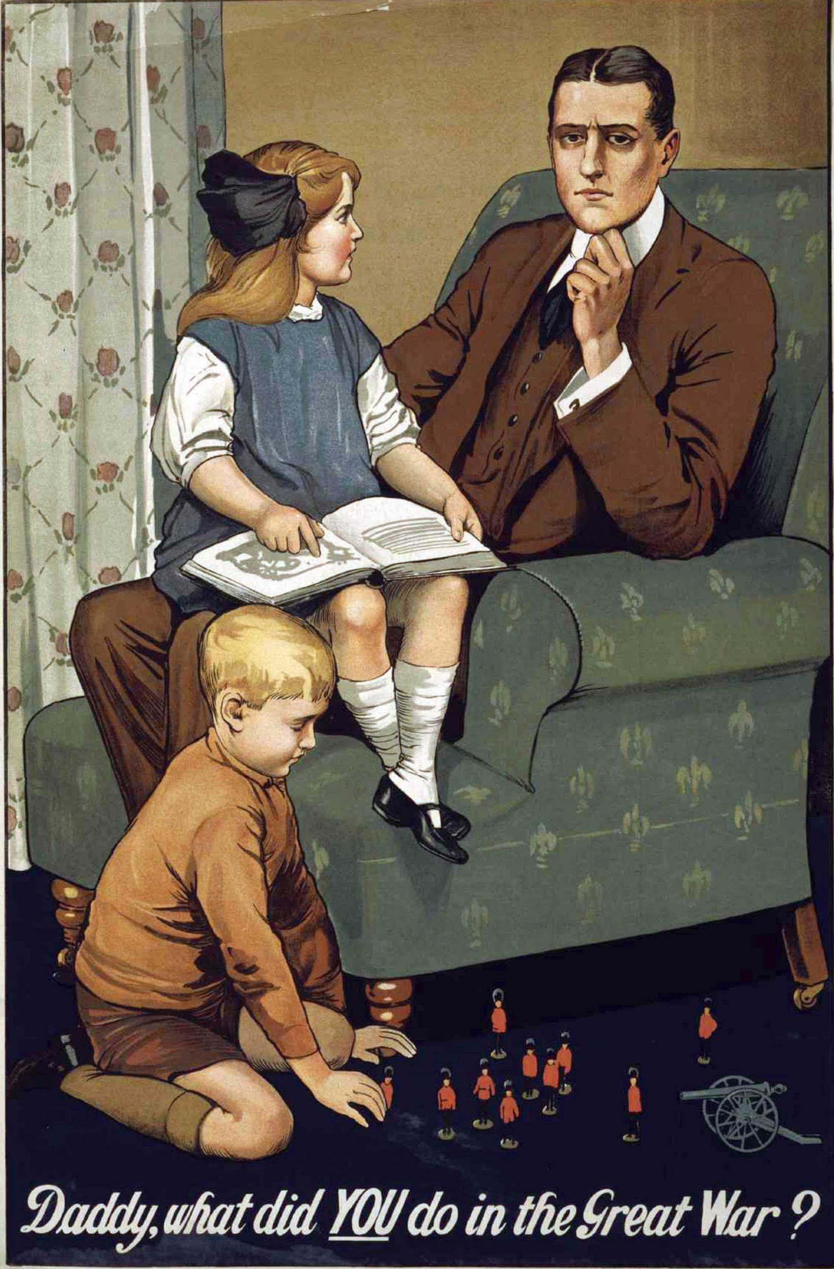

Symbols of nationhood
Once the initial euphoria (‘war fever’) had subsided, it was imperative to remind people, both at home and in the trenches, of what they were fighting for. The major themes included a call to arms and a request for war loans; as well as efforts to encourage industrial activity, to explain national policies, to channel emotions such as courage or hatred, to urge the population to conserve resources, and to inform the public of food and fuel substitutes.
One tactic at a state’s disposal was the use of iconic figures to strengthen a particular point about national identity in order to promote patriotism. These might be real people presented in a mythologised form as national heroes, or they might come from old myths or popular folklore:

An alternative strategy was the use of material symbols of nationhood. Indeed, a state might have numerous opportunities at its disposal to create narratives and circulate images favourable to its preferred national story - in everyday items such as coins, banknotes and postage stamps, or symbolic structures such as statues, monuments and buildings. Two of the most overt and powerful symbols, which allow citizens to express their affinity with the state, are the nation’s flag and its anthem.

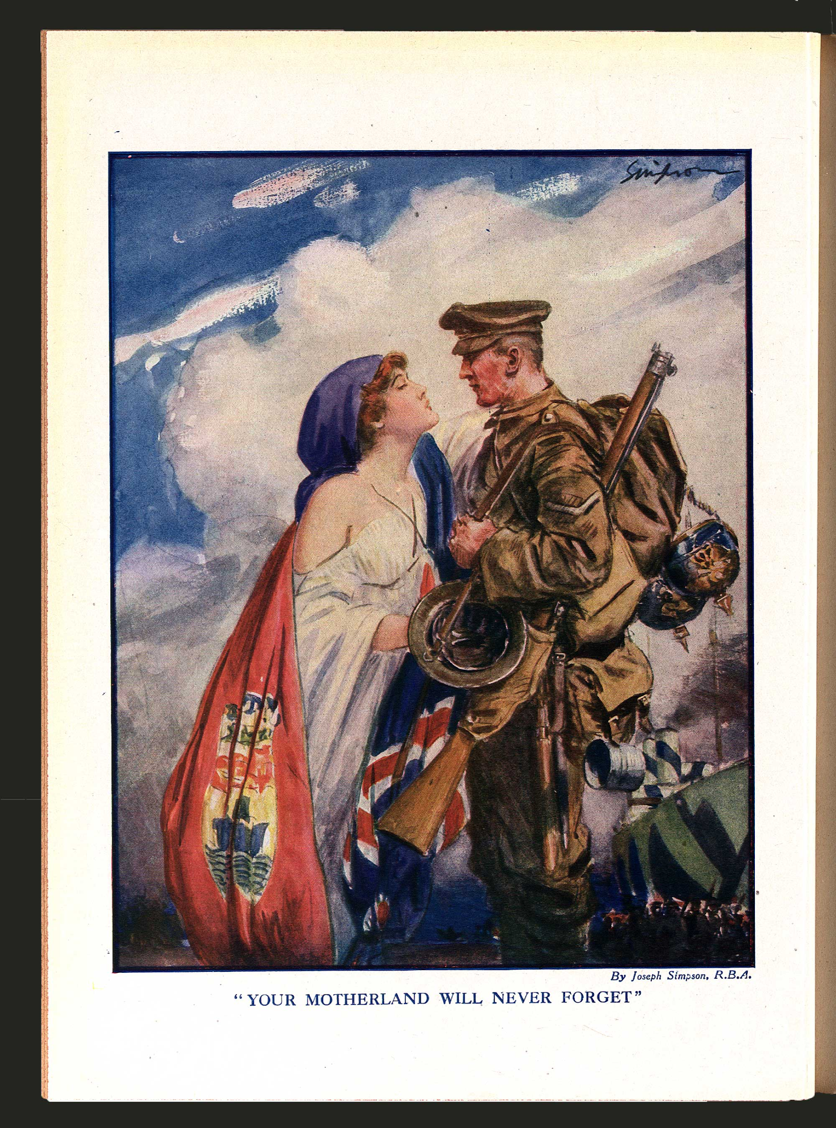

The money motif
The need to raise money to pay for the war by means of war bonds (or ‘Liberty Bonds’ as they were known in the United States) provided one of the most important patriotic themes for posters and for the new medium of film. A recurring, related theme was the portrayal of money (coins and banknotes) as an active force in military engagement, for example: ‘Turn Your Silver into Bullets - at the Post Office’. In France, a similar poster, designed by Jules Abel Faivre in 1915, depicted a large gold coin with a Gallic cockerel on it, crushing a German soldier, with the slogan: ‘Deposit Your Gold for France - Gold Fights for Victory’.
All sides, therefore, supplemented their military engagement with propaganda aimed at stimulating national sentiment by means of nationalistic slogans and patriotic calls to arms.

Atrocity Propaganda

Atrocity propaganda focused on the most violent acts committed by the German and Austro-Hungarian armies, emphasising their barbarity and providing justification for the conflict.

Victims shot, bayoneted to death, killed with knives, arms lopped off, torn off, or broken, legs broken, nose cut off, ears cut off, eyes put out, genital organs cut off, victims stoned, women violated and killed, breasts cut off, persons hanged, victims burnt alive, one child thrown to the pigs, victims clubbed to death with butt-ends of rifles or sticks, victims impaled, victims whose skin was cut into strips.

Professor R A Reiss, a prominent forensic scientist commissioned by the Serbian Prime Minister to conduct an enquiry into war crimes, thus categorised the numerous violent acts against civilians perpetrated by the occupying Austro-Hungarian forces in Serbia in 1914. His account bore striking similarities to French and British publications of the same period, notably Le livre rouge des atrocités allemandes and the Bryce Report. In painstaking detail, such reports recorded the crimes of 1914, individual acts of violence against civilians, troops and prisoners of war; looting and pillage; the use of weapons ‘forbidden by the rules and conventions of war’; the destruction of ancient libraries and cathedrals, and of homes and villages; rape, mutilation, and torture. Vivid illustrations and first-hand testimonies accompanied each description of the ‘crimes without name’, while Liège, Louvain, Dinant, Antwerp, Reims, Arras, and Senlis were transformed into ‘martyred towns’, ravaged by an uncompromising, inhuman enemy whose victims ranged from children to the elderly, from men of God to the injured and helpless. Such images dominated the early propaganda of the Great War, serving as a potent reminder of the justification for war and a vindication of the sacrifice it demanded.

The nature of atrocity propaganda
Atrocity propaganda varied, appearing in books, newspapers, pamphlets, sketches, posters, films, lantern slides, and cartoons, and on postcards, plates, cups, and medals. It operated on many levels. Official government reports presented ‘evidence’ that German troops had contravened the Hague Conventions of 1899 and 1907. Eyewitness accounts from victims and perpetrators made for compelling and convincing reading, and, although methods of investigation often fell short of legal standards, the reports appeared to be based on irrefutable facts. That respected experts led these enquiries (Bryce, for example, having served as a British Ambassador to the United States, member of the House of Lords, and jurist) further legitimised the allegations.

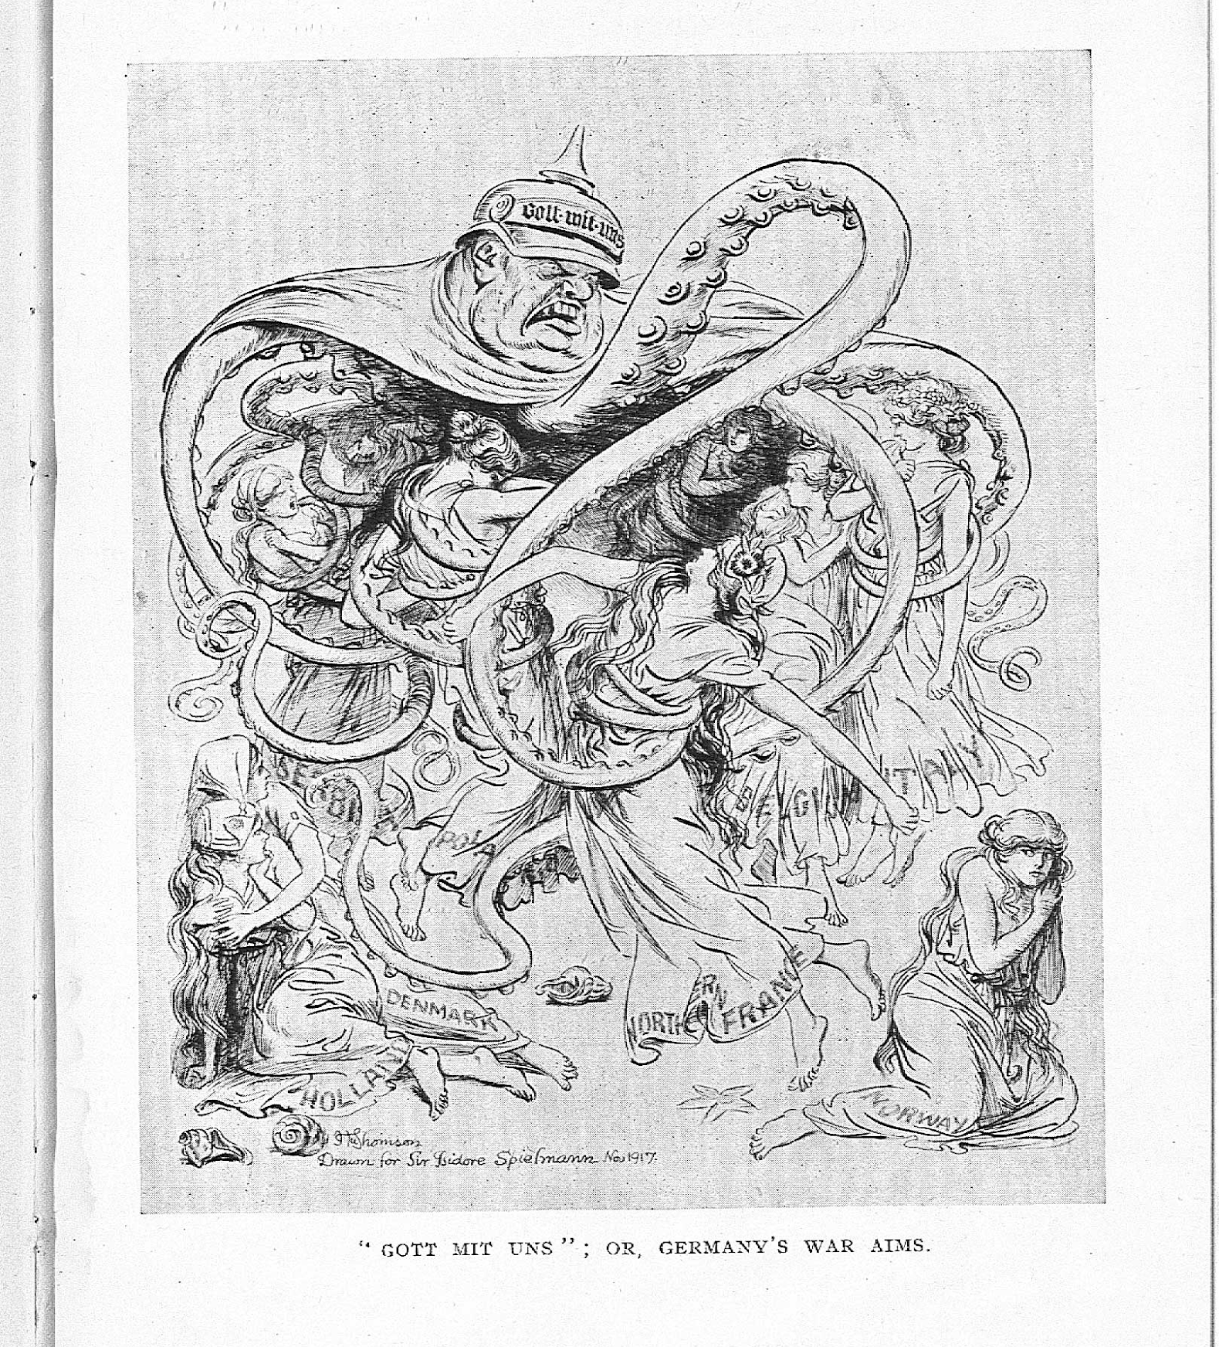

Legacy
In the inter-war period, investigations into the nature of war propaganda suggested that atrocity stories had been fabricated by the Allies in order to justify the war and to encourage enlistment.

